南京理工大学紫金学院

《Java Web开发基础》实验报告



课程编号： | 03415011
课程名称： | Java Web开发基础
学 院： | 计算机学院
专 业： | 计算机科学与技术
学 号： | 2315302125
姓 名： | 崔子霖
任课教师： | 童安玲

2026年5月

大作业 Spring Boot + Spring框架 + MyBatis实现MySQL增删改查
- 实验目的
1. 了解 Spring Boot、Spring MVC、MyBatis 和 MySQL 在 Java Web 项目中的基本作用。
2. 掌握使用 JSP 页面、Controller、Service、Mapper 分层完成用户注册、登录、查询、修改和删除的开发流程。
3. 掌握 MyBatis XML 映射文件编写、数据库初始化脚本配置以及 Web 项目打包运行的方法。

- 实验内容
本次大作业实现了一个用户信息管理系统。系统默认连接 MySQL 数据库 javaweb_bigwork，数据库连接配置写在 application.properties 中，使用 users 表保存用户信息。页面层使用 JSP，控制层通过 Spring MVC 注解接收表单请求，业务层由 UserService 处理注册、登录、查询、修改、删除逻辑，持久层通过 MyBatis Mapper 执行 SQL。
运行方式：先启动本机 MySQL 服务，然后在项目根目录执行 mvn -DskipTests package，再执行 java -jar target/sencondTest.war，浏览器访问 http://localhost:8080/sencondTest/bigwork/login。默认登录账号为“崔子霖”，密码为“2315302125”。
Maven 依赖配置（pom.xml）
<project xmlns="http://maven.apache.org/POM/4.0.0" xmlns:xsi="http://www.w3.org/2001/XMLSchema-instance"
xsi:schemaLocation="http://maven.apache.org/POM/4.0.0 http://maven.apache.org/maven-v4_0_0.xsd">
<modelVersion>4.0.0</modelVersion>
<groupId>org.example</groupId>
<artifactId>sencondTest</artifactId>
<packaging>war</packaging>
<version>1.0-SNAPSHOT</version>
<name>sencondTest Maven Webapp</name>
<url>http://maven.apache.org</url>
<properties>
<spring.boot.version>2.7.18</spring.boot.version>
<mybatis.spring.boot.version>2.3.2</mybatis.spring.boot.version>
<maven.compiler.source>8</maven.compiler.source>
<maven.compiler.target>8</maven.compiler.target>
<project.build.sourceEncoding>UTF-8</project.build.sourceEncoding>
</properties>
<dependencyManagement>
<dependencies>
<dependency>
<groupId>org.springframework.boot</groupId>
<artifactId>spring-boot-dependencies</artifactId>
<version>${spring.boot.version}</version>
<type>pom</type>
<scope>import</scope>
</dependency>
</dependencies>
</dependencyManagement>
<dependencies>
<dependency>
<groupId>org.springframework.boot</groupId>
<artifactId>spring-boot-starter-web</artifactId>
<version>${spring.boot.version}</version>
</dependency>
<dependency>
<groupId>org.mybatis.spring.boot</groupId>
<artifactId>mybatis-spring-boot-starter</artifactId>
<version>${mybatis.spring.boot.version}</version>
</dependency>
<dependency>
<groupId>org.apache.tomcat.embed</groupId>
<artifactId>tomcat-embed-jasper</artifactId>
<version>9.0.83</version>
</dependency>
<dependency>
<groupId>javax.servlet</groupId>
<artifactId>jstl</artifactId>
<version>1.2</version>
</dependency>
<dependency>
<groupId>javax.servlet</groupId>
<artifactId>javax.servlet-api</artifactId>
<version>4.0.1</version>
<scope>provided</scope>
</dependency>
<dependency>
<groupId>com.mysql</groupId>
<artifactId>mysql-connector-j</artifactId>
<version>8.4.0</version>
</dependency>
<dependency>
<groupId>junit</groupId>
<artifactId>junit</artifactId>
<version>3.8.1</version>
<scope>test</scope>
</dependency>
</dependencies>
<build>
<finalName>sencondTest</finalName>
<plugins>
<plugin>
<groupId>org.springframework.boot</groupId>
<artifactId>spring-boot-maven-plugin</artifactId>
<version>${spring.boot.version}</version>
<executions>
<execution>
<goals>
<goal>repackage</goal>
</goals>
</execution>
</executions>
<configuration>
<mainClass>org.example.BigWorkApplication</mainClass>
</configuration>
</plugin>
</plugins>
</build>
</project>
Spring Boot 默认 MySQL 配置（src/main/resources/application.properties）
server.port=8080
server.servlet.context-path=/sencondTest
spring.mvc.view.prefix=/WEB-INF/views/
spring.mvc.view.suffix=.jsp
spring.datasource.driver-class-name=com.mysql.cj.jdbc.Driver
spring.datasource.url=jdbc:mysql://localhost:3306/javaweb_bigwork?useSSL=false&serverTimezone=Asia/Shanghai&characterEncoding=UTF-8&createDatabaseIfNotExist=true&allowPublicKeyRetrieval=true
spring.datasource.username=root
spring.datasource.password=
spring.sql.init.mode=always
spring.sql.init.encoding=UTF-8
mybatis.mapper-locations=classpath:mapper/*.xml
mybatis.type-aliases-package=org.example.bigwork.entity
mybatis.configuration.map-underscore-to-camel-case=true
Spring Boot 启动类（src/main/java/org/example/BigWorkApplication.java）
package org.example;
import org.mybatis.spring.annotation.MapperScan;
import org.springframework.boot.SpringApplication;
import org.springframework.boot.autoconfigure.SpringBootApplication;
import org.springframework.boot.web.servlet.ServletComponentScan;
@SpringBootApplication
@ServletComponentScan
@MapperScan("org.example.bigwork.mapper")
public class BigWorkApplication {
public static void main(String[] args) {
SpringApplication.run(BigWorkApplication.class, args);
}
}
用户实体类（src/main/java/org/example/bigwork/entity/User.java）
package org.example.bigwork.entity;
public class User {
private Integer id;
private String username;
private String password;
private String realName;
private String studentNo;
public Integer getId() {
return id;
}
public void setId(Integer id) {
this.id = id;
}
public String getUsername() {
return username;
}
public void setUsername(String username) {
this.username = username;
}
public String getPassword() {
return password;
}
public void setPassword(String password) {
this.password = password;
}
public String getRealName() {
return realName;
}
public void setRealName(String realName) {
this.realName = realName;
}
public String getStudentNo() {
return studentNo;
}
public void setStudentNo(String studentNo) {
this.studentNo = studentNo;
}
}
MyBatis Mapper 接口（src/main/java/org/example/bigwork/mapper/UserMapper.java）
package org.example.bigwork.mapper;
import java.util.List;
import org.apache.ibatis.annotations.Param;
import org.example.bigwork.entity.User;
public interface UserMapper {
int insert(User user);
User findByUsernameAndPassword(@Param("username") String username, @Param("password") String password);
User findByUsername(@Param("username") String username);
List<User> findAll();
int update(User user);
int deleteById(@Param("id") Integer id);
}
业务服务类（src/main/java/org/example/bigwork/service/UserService.java）
package org.example.bigwork.service;
import java.util.List;
import org.example.bigwork.entity.User;
import org.example.bigwork.mapper.UserMapper;
import org.springframework.stereotype.Service;
import org.springframework.util.StringUtils;
@Service
public class UserService {
private final UserMapper userMapper;
public UserService(UserMapper userMapper) {
this.userMapper = userMapper;
}
public boolean register(User user) {
if (!hasText(user.getUsername()) || !hasText(user.getPassword())) {
return false;
}
if (userMapper.findByUsername(user.getUsername()) != null) {
return false;
}
return userMapper.insert(user) > 0;
}
public User login(String username, String password) {
if (!hasText(username) || !hasText(password)) {
return null;
}
return userMapper.findByUsernameAndPassword(username, password);
}
public List<User> listUsers() {
return userMapper.findAll();
}
public boolean update(User user) {
if (user.getId() == null || !hasText(user.getUsername()) || !hasText(user.getPassword())) {
return false;
}
return userMapper.update(user) > 0;
}
public boolean delete(Integer id) {
return id != null && userMapper.deleteById(id) > 0;
}
private boolean hasText(String value) {
return StringUtils.hasText(value);
}
}
控制器类（src/main/java/org/example/bigwork/controller/UserController.java）
package org.example.bigwork.controller;
import javax.servlet.http.HttpSession;
import org.example.bigwork.entity.User;
import org.example.bigwork.service.UserService;
import org.springframework.stereotype.Controller;
import org.springframework.ui.Model;
import org.springframework.web.bind.annotation.GetMapping;
import org.springframework.web.bind.annotation.ModelAttribute;
import org.springframework.web.bind.annotation.PostMapping;
import org.springframework.web.bind.annotation.RequestMapping;
import org.springframework.web.bind.annotation.RequestParam;
import org.springframework.web.servlet.mvc.support.RedirectAttributes;
@Controller
@RequestMapping("/bigwork")
public class UserController {
private final UserService userService;
public UserController(UserService userService) {
this.userService = userService;
}
@GetMapping({"", "/", "/login"})
public String loginPage(Model model) {
if (!model.containsAttribute("user")) {
User user = new User();
user.setUsername("崔子霖");
user.setPassword("2315302125");
model.addAttribute("user", user);
}
return "bigwork/login";
}
@PostMapping("/login")
public String login(@RequestParam String username, @RequestParam String password,
HttpSession session, RedirectAttributes redirectAttributes) {
User user = userService.login(username, password);
if (user == null) {
redirectAttributes.addFlashAttribute("message", "用户名或密码错误，请重新登录。");
return "redirect:/bigwork/login";
}
session.setAttribute("loginUser", user);
return "redirect:/bigwork/users";
}
@GetMapping("/register")
public String registerPage(Model model) {
if (!model.containsAttribute("user")) {
User user = new User();
user.setUsername("崔子霖");
user.setPassword("2315302125");
user.setRealName("崔子霖");
user.setStudentNo("2315302125");
model.addAttribute("user", user);
}
return "bigwork/register";
}
@PostMapping("/register")
public String register(@ModelAttribute User user, RedirectAttributes redirectAttributes) {
if (userService.register(user)) {
redirectAttributes.addFlashAttribute("message", "注册成功，请使用新账号登录。");
return "redirect:/bigwork/login";
}
redirectAttributes.addFlashAttribute("message", "注册失败，用户名不能为空或已存在。");
redirectAttributes.addFlashAttribute("user", user);
return "redirect:/bigwork/register";
}
@GetMapping("/users")
public String users(Model model, HttpSession session) {
User loginUser = (User) session.getAttribute("loginUser");
if (loginUser == null) {
return "redirect:/bigwork/login";
}
model.addAttribute("loginUser", loginUser);
model.addAttribute("users", userService.listUsers());
return "bigwork/users";
}
@PostMapping("/users/update")
public String update(@ModelAttribute User user, RedirectAttributes redirectAttributes) {
redirectAttributes.addFlashAttribute("message", userService.update(user) ? "用户修改成功。" : "用户修改失败。");
return "redirect:/bigwork/users";
}
@GetMapping("/users/delete")
public String delete(@RequestParam Integer id, RedirectAttributes redirectAttributes) {
redirectAttributes.addFlashAttribute("message", userService.delete(id) ? "用户删除成功。" : "用户删除失败。");
return "redirect:/bigwork/users";
}
@GetMapping("/logout")
public String logout(HttpSession session) {
session.invalidate();
return "redirect:/bigwork/login";
}
}
MyBatis SQL 映射文件（src/main/resources/mapper/UserMapper.xml）
<?xml version="1.0" encoding="UTF-8" ?>
<!DOCTYPE mapper
PUBLIC "-//mybatis.org//DTD Mapper 3.0//EN"
"http://mybatis.org/dtd/mybatis-3-mapper.dtd">
<mapper namespace="org.example.bigwork.mapper.UserMapper">
<resultMap id="UserResultMap" type="org.example.bigwork.entity.User">
<id property="id" column="id"/>
<result property="username" column="username"/>
<result property="password" column="password"/>
<result property="realName" column="real_name"/>
<result property="studentNo" column="student_no"/>
</resultMap>
<insert id="insert" parameterType="org.example.bigwork.entity.User" useGeneratedKeys="true" keyProperty="id">
INSERT INTO users (username, password, real_name, student_no)
VALUES (#{username}, #{password}, #{realName}, #{studentNo})
</insert>
<select id="findByUsernameAndPassword" resultMap="UserResultMap">
SELECT id, username, password, real_name, student_no
FROM users
WHERE username = #{username} AND password = #{password}
</select>
<select id="findByUsername" resultMap="UserResultMap">
SELECT id, username, password, real_name, student_no
FROM users
WHERE username = #{username}
</select>
<select id="findAll" resultMap="UserResultMap">
SELECT id, username, password, real_name, student_no
FROM users
ORDER BY id
</select>
<update id="update" parameterType="org.example.bigwork.entity.User">
UPDATE users
SET username = #{username},
password = #{password},
real_name = #{realName},
student_no = #{studentNo}
WHERE id = #{id}
</update>
<delete id="deleteById">
DELETE FROM users
WHERE id = #{id}
</delete>
</mapper>
数据库建表脚本（src/main/resources/schema.sql）
CREATE TABLE IF NOT EXISTS users (
id INT AUTO_INCREMENT PRIMARY KEY,
username VARCHAR(50) NOT NULL UNIQUE,
password VARCHAR(50) NOT NULL,
real_name VARCHAR(50),
student_no VARCHAR(30),
create_time TIMESTAMP DEFAULT CURRENT_TIMESTAMP
);
初始化数据脚本（src/main/resources/data.sql）
INSERT INTO users (username, password, real_name, student_no)
SELECT '崔子霖', '2315302125', '崔子霖', '2315302125'
WHERE NOT EXISTS (SELECT 1 FROM users WHERE username = '崔子霖');
INSERT INTO users (username, password, real_name, student_no)
SELECT 'teacher', '123456', '测试教师', 'T001'
WHERE NOT EXISTS (SELECT 1 FROM users WHERE username = 'teacher');
INSERT INTO users (username, password, real_name, student_no)
SELECT 'student', '888888', '测试学生', 'S001'
WHERE NOT EXISTS (SELECT 1 FROM users WHERE username = 'student');
登录页面 JSP（src/main/webapp/WEB-INF/views/bigwork/login.jsp）
<%@ page contentType="text/html; charset=UTF-8" language="java" %>
<%@ taglib prefix="c" uri="http://java.sun.com/jsp/jstl/core" %>
<!DOCTYPE html>
<html>
<head>
<meta charset="UTF-8">
<title>大作业 - 用户登录</title>
<link rel="stylesheet" href="${pageContext.request.contextPath}/bigwork.css">
</head>
<body>
<main class="page">
<section class="panel">
<h1>Spring Boot + Spring + MyBatis 用户管理系统</h1>
<p class="subtitle">姓名：崔子霖 学号：2315302125</p>
<c:if test="${not empty message}">
<p class="message">${message}</p>
</c:if>
<form action="${pageContext.request.contextPath}/bigwork/login" method="post" class="form">
<label>用户名
<input type="text" name="username" value="${user.username}" required>
</label>
<label>密码
<input type="password" name="password" value="${user.password}" required>
</label>
<button type="submit">登录</button>
</form>
<p class="link-row">
<a href="${pageContext.request.contextPath}/bigwork/register">注册新用户</a>
</p>
</section>
</main>
</body>
</html>
注册页面 JSP（src/main/webapp/WEB-INF/views/bigwork/register.jsp）
<%@ page contentType="text/html; charset=UTF-8" language="java" %>
<%@ taglib prefix="c" uri="http://java.sun.com/jsp/jstl/core" %>
<!DOCTYPE html>
<html>
<head>
<meta charset="UTF-8">
<title>大作业 - 用户注册</title>
<link rel="stylesheet" href="${pageContext.request.contextPath}/bigwork.css">
</head>
<body>
<main class="page">
<section class="panel">
<h1>注册用户</h1>
<p class="subtitle">注册、登录、查询、修改、删除均通过 Spring MVC Controller 调用 UserService，再由 MyBatis 操作数据库。</p>
<c:if test="${not empty message}">
<p class="message">${message}</p>
</c:if>
<form action="${pageContext.request.contextPath}/bigwork/register" method="post" class="form">
<label>用户名
<input type="text" name="username" value="${user.username}" required>
</label>
<label>密码
<input type="text" name="password" value="${user.password}" required>
</label>
<label>姓名
<input type="text" name="realName" value="${user.realName}">
</label>
<label>学号
<input type="text" name="studentNo" value="${user.studentNo}">
</label>
<button type="submit">注册</button>
</form>
<p class="link-row">
<a href="${pageContext.request.contextPath}/bigwork/login">返回登录</a>
</p>
</section>
</main>
</body>
</html>
用户管理页面 JSP（src/main/webapp/WEB-INF/views/bigwork/users.jsp）
<%@ page contentType="text/html; charset=UTF-8" language="java" %>
<%@ taglib prefix="c" uri="http://java.sun.com/jsp/jstl/core" %>
<!DOCTYPE html>
<html>
<head>
<meta charset="UTF-8">
<title>大作业 - 用户管理</title>
<link rel="stylesheet" href="${pageContext.request.contextPath}/bigwork.css">
</head>
<body>
<main class="page wide">
<section class="panel">
<div class="topbar">
<div>
<h1>用户信息管理</h1>
<p class="subtitle">当前登录：${loginUser.realName}（${loginUser.studentNo}），用户名：${loginUser.username}</p>
</div>
<a class="button secondary" href="${pageContext.request.contextPath}/bigwork/logout">退出</a>
</div>
<c:if test="${not empty message}">
<p class="message">${message}</p>
</c:if>
<table class="user-table">
<thead>
<tr>
<th>ID</th>
<th>用户名</th>
<th>密码</th>
<th>姓名</th>
<th>学号</th>
<th>修改</th>
<th>删除</th>
</tr>
</thead>
<tbody>
<c:forEach var="item" items="${users}">
<tr>
<form action="${pageContext.request.contextPath}/bigwork/users/update" method="post">
<td>
${item.id}
<input type="hidden" name="id" value="${item.id}">
</td>
<td><input type="text" name="username" value="${item.username}" required></td>
<td><input type="text" name="password" value="${item.password}" required></td>
<td><input type="text" name="realName" value="${item.realName}"></td>
<td><input type="text" name="studentNo" value="${item.studentNo}"></td>
<td><button type="submit" class="small">保存</button></td>
<td><a class="danger" href="${pageContext.request.contextPath}/bigwork/users/delete?id=${item.id}">删除</a></td>
</form>
</tr>
</c:forEach>
</tbody>
</table>
<p class="link-row">
<a href="${pageContext.request.contextPath}/bigwork/register">继续注册新用户</a>
</p>
</section>
</main>
</body>
</html>
页面样式文件（src/main/webapp/bigwork.css）
body {
margin: 0;
font-family: Arial, "Microsoft YaHei", sans-serif;
background: #f4f6f8;
color: #1f2933;
}
.page {
min-height: 100vh;
display: flex;
align-items: center;
justify-content: center;
padding: 32px;
box-sizing: border-box;
}
.wide {
align-items: flex-start;
}
.panel {
width: min(920px, 100%);
background: #fff;
border: 1px solid #d7dde3;
border-radius: 8px;
padding: 28px;
box-shadow: 0 14px 34px rgba(15, 23, 42, 0.08);
}
h1 {
margin: 0 0 10px;
font-size: 26px;
}
.subtitle {
margin: 0 0 22px;
color: #52616f;
}
.message {
border-left: 4px solid #2563eb;
background: #eef4ff;
padding: 10px 12px;
}
.form {
display: grid;
gap: 16px;
}
label {
display: grid;
gap: 7px;
font-weight: 600;
}
input {
box-sizing: border-box;
width: 100%;
border: 1px solid #cbd5e1;
border-radius: 6px;
padding: 9px 10px;
font: inherit;
}
button,
.button {
border: 0;
border-radius: 6px;
background: #2563eb;
color: #fff;
font: inherit;
padding: 10px 16px;
cursor: pointer;
text-decoration: none;
text-align: center;
}
.secondary {
background: #475569;
}
.small {
padding: 7px 10px;
}
.link-row {
margin: 18px 0 0;
}
a {
color: #1d4ed8;
}
.topbar {
display: flex;
justify-content: space-between;
gap: 18px;
align-items: flex-start;
}
.user-table {
width: 100%;
border-collapse: collapse;
}
.user-table th,
.user-table td {
border: 1px solid #d7dde3;
padding: 8px;
text-align: left;
}
.user-table th {
background: #f1f5f9;
}
.danger {
color: #b91c1c;
}
运行结果截图
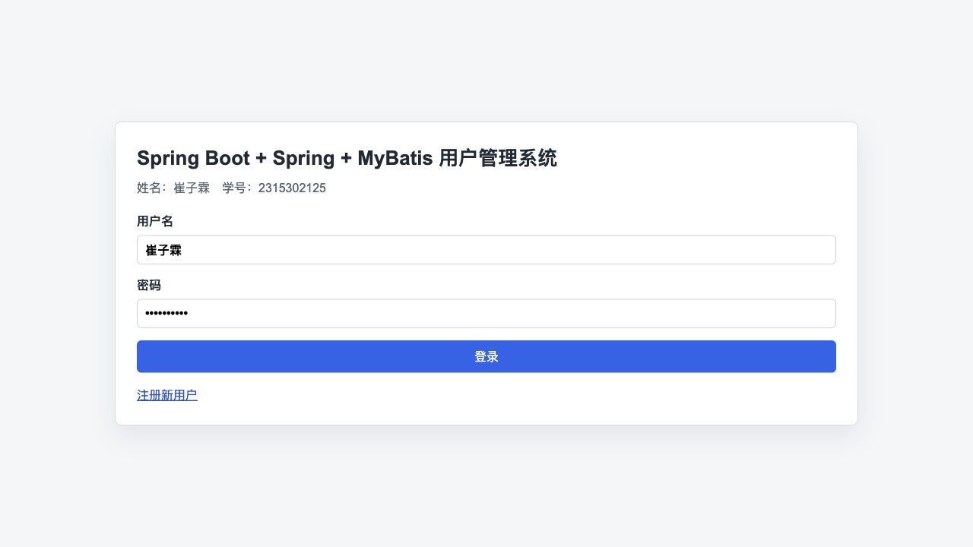
图1 登录页面，显示姓名和学号，并以姓名作为用户名、学号作为密码。
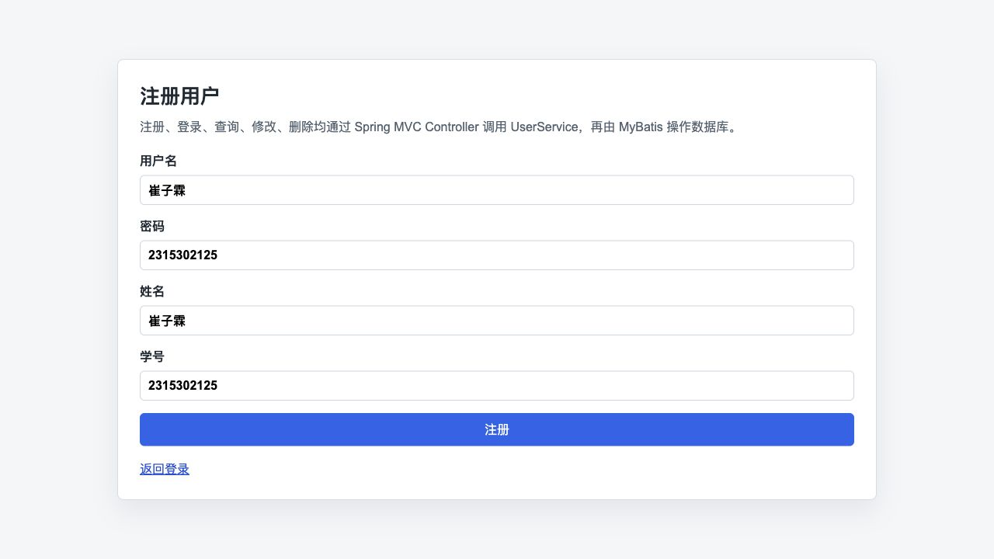
图2 注册页面，可录入用户名、密码、姓名和学号。
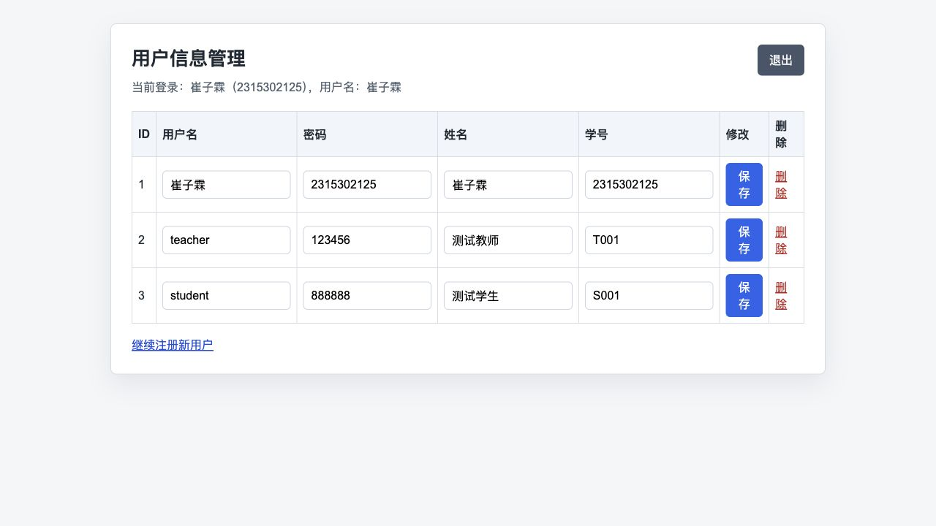
图3 用户管理页面，可查询全部用户，并支持修改和删除。

- 实验总结
通过本次大作业，我进一步熟悉了 Spring Boot 项目的组织结构，理解了 Controller、Service、Mapper 三层协作完成业务功能的方式。
在实现过程中，重点处理了 JSP 视图解析、MySQL 数据库连接、schema.sql/data.sql 初始化、MyBatis XML 命名空间和实体字段映射等问题。
最终系统能够完成用户注册、登录、查询、修改和删除等基本功能，页面截图中包含本人姓名和学号，达到了实验指导书中对大作业的要求。

